Group 3 Assignement

Table of Contents

Introduction 3

Libraries 3

Summary of the data 3

Fig. 1 3

Data Plot 3

Fig. 2 3

Explanation for the visualization 4

Fig. 3 4

Fig. 4 6

Gev Parameters 6

Fig. 5 6

Explanation 6

Fig. 6 7

Explanation 7

Calculation of the return level 7

Fig. 7 8

Fig. 8 8

Var Calculation 8

References 9

# Introduction

## Libraries

1. extRemes
2. ismev

## Summary of the data

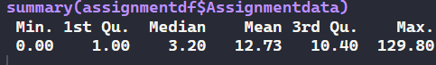

### Fig. 1

Data Plot

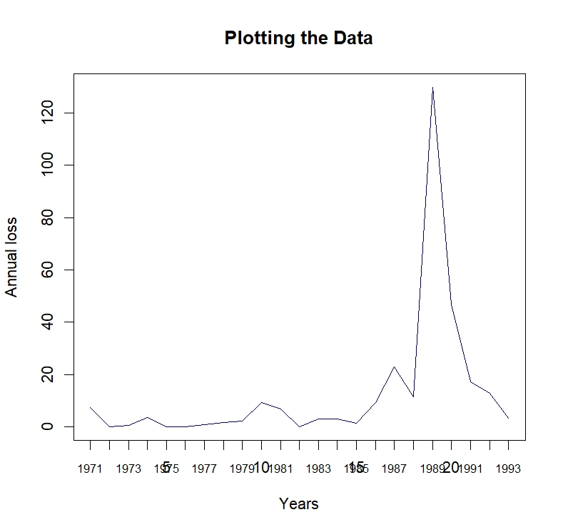

### Fig. 2

Explanation for the visualization

On summary, the dataset has a minimum of 0, the 1st quartile of 1, the median value of 3.20, mean of 12.73, and the 3rd quartile of 10.40 and the maximum value of 129.80. Based on the summary there is a larger range of values between the minimum of 0.00 and the maximum value of 129.80 suggesting the possibility of outliers and therefore the extremes are available and can be estimated.

The presence of outliers in a dataset as shown in the figure below can significantly impact the statistical analysis, especially when modeling extreme values. Outliers are data points that deviate substantially from the overall pattern of the data, and they can distort the estimation of distribution parameters. In your case, as revealed by the plot of the Generalized Extreme Value (GEV) distribution, the existence of outliers prompts a closer examination of extreme values to better understand their characteristics and potential impact.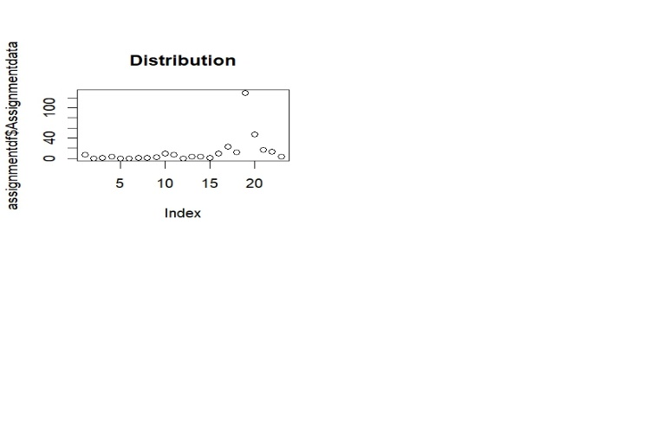

### Fig. 3

The GEV distribution is commonly employed for modeling extreme events, such as the tails of a distribution where outliers may occur. Its flexibility allows for capturing various shapes of extreme value distributions, making it suitable for analyzing data with heavy tails.

To further examine extreme values, it's important to investigate the tails of the distribution. This involves focusing on the parameters of the GEV distribution, namely location, scale, and shape. The location parameter represents the location of the distribution, the scale parameter controls the spread, and the shape parameter influences the tail behavior. Outliers can notably affect the estimation of these parameters, necessitating robust methods or data pre-processing techniques.

Consideration should be given to identifying and potentially removing outliers before fitting the GEV distribution. Techniques like outlier detection or robust estimation methods can be employed for this purpose. Once outliers are addressed, the GEV distribution can be fitted more reliably, leading to more accurate parameter estimates.

Moreover, understanding the extreme values is crucial for risk assessment and management. Calculating metrics such as the Value at Risk (VaR) or return levels relies on precise parameter estimates from the GEV distribution (Alentorn & Markose, n.d.). By exploring the extremes, you gain insights into tail behavior, which is vital for making informed decisions in scenarios involving rare and extreme events.

In summary, acknowledging and addressing outliers, particularly when fitting distributions like GEV, is fundamental for robust statistical analysis. The careful examination of extreme values enhances the reliability of parameter estimates and contributes to a more accurate representation of the tail behavior in your data.

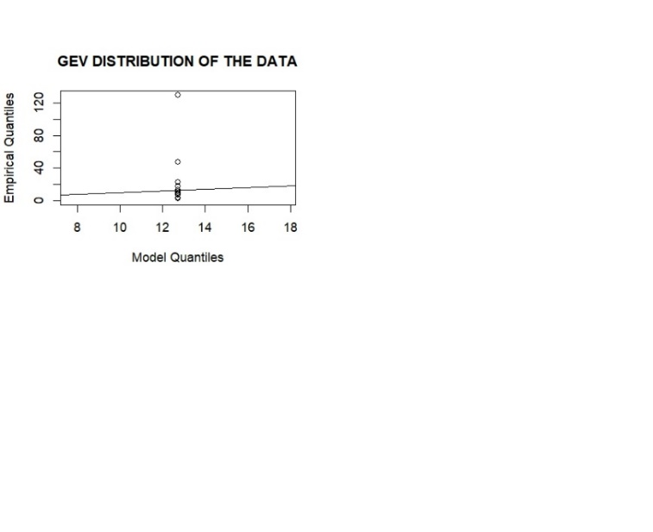

### Fig. 4

# Gev Parameters

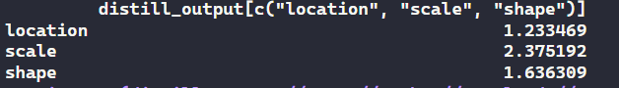

### Fig. 5

## Explanation

In order to calculate the VaR, there must a shape parameter, location parameter and the scale parameter. Fig.3 shows the estimated parameters.

1. plot(fit1, "trace")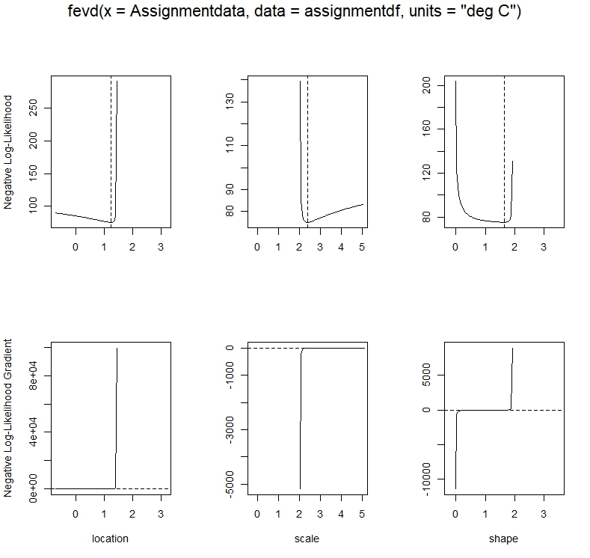

### Fig. 6

## Explanation

From the plots it is evident that the properties below exists:

1. **Convergence**
2. **Stationarity**

# Calculation of the return level

1. return.level(fit1)

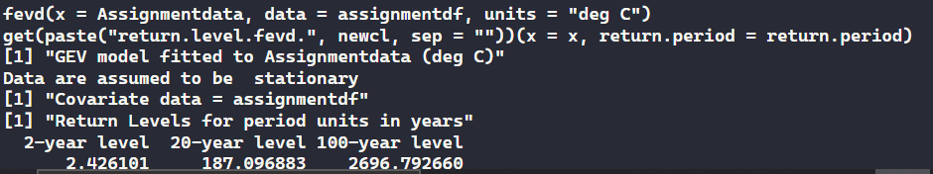

### Fig. 7

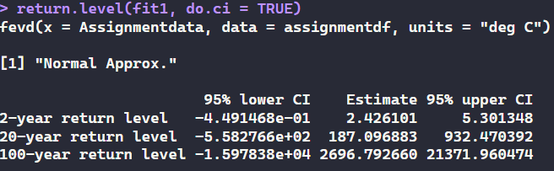

### Fig. 8

Fig. 6 shows the return level for a 2-year level, 20 year level and 100 year level. The 2 year level return level of 2.426101 is slightly equal to the scale parameter of 2.375192.

# Var Calculation

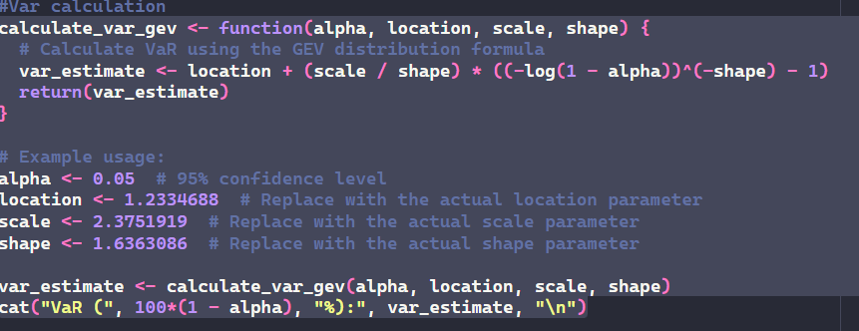

output

(VaR 95 %): 187.0969

# References

Alentorn, A., & Markose, S. M. (n.d.). *Generalized Extreme Value Distribution and Extreme Economic Value at Risk (EE-VaR)*. Springer eBooks. <https://doi.org/10.1007/978-3-540-77958-2_3>

Gilleland, E., & Katz, R. W. (n.d.). *extRemes2.0: An Extreme Value Analysis Package inR*. Journal of Statistical Software. https://doi.org/10.18637/jss.v072.i08